VoIP
Quick Start Guide

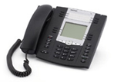
53i 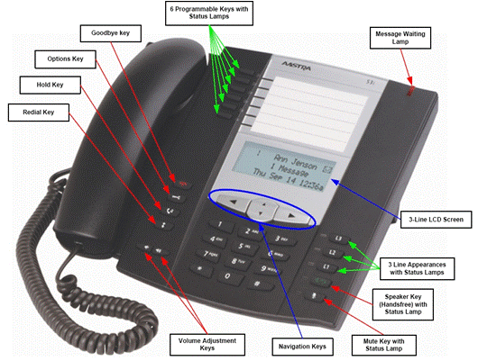
55i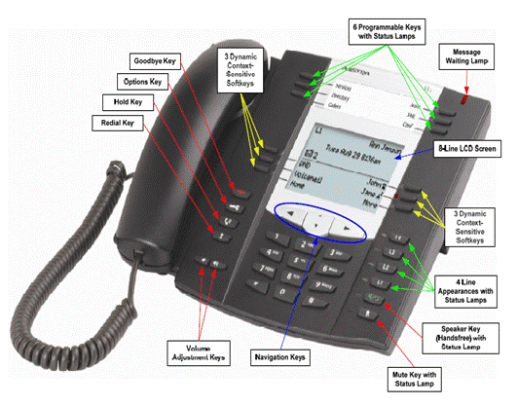
57i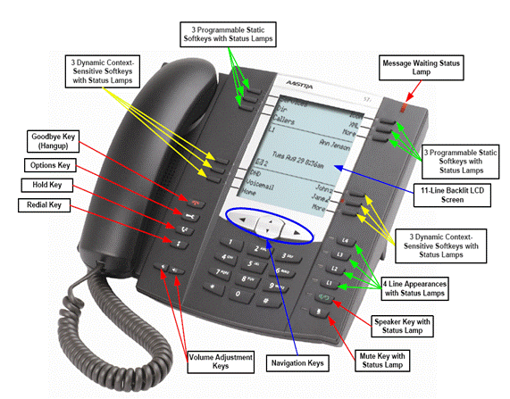
Please note that, at the University of Minnesota, the symbols indicated for each key have been replaced with the name of each key.
ANSWER A CALL
To ANSWER a ringing line, simply pick up the handset or press the speaker button.
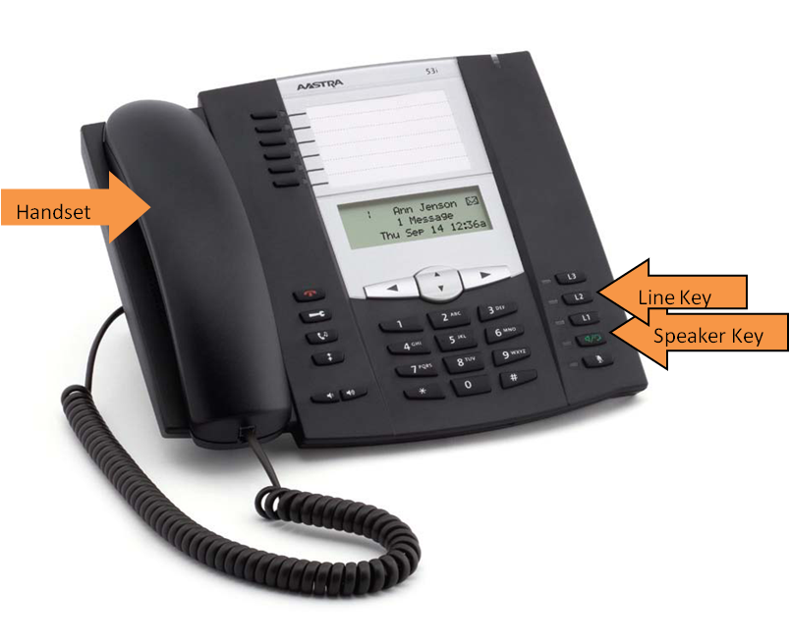
To HANG UP from an active call, you may replace the handset in its cradle or press the Goodbye (Hangup) key.

PLACE A CALL
Get an internal dial tone by removing the handset from its cradle or pressing the speaker key.
If you are calling a number within the University telephone system, you may place the call by simply dialing the last five digits of the telephone number. Telephone numbers within the University system begin with:
- 612-624-XXXX;
- 612-625-XXXX;
- 612-626-XXXX;
- 612-627-0XXX (probably a University Centrex number);
- 612-627-1XXX (probably a University Centrex number);
- 612-627-4XXX (probably a University Centrex number);
- 612-627-6XXX (probably a University Centrex number) and
- 612-301-XXXX.
If you are calling a number outside of the University telephone system, dial an “8” (you will not hear an “outside” dial tone) and then dial the telephone number. You do not need to dial a “1” at the beginning of a long distance number.
(A busy line will return a slow busy signal to you. If you receive a faster than normal busy signal, all facilities carrying calls outside of the University, or all lines in the area of the call’s destination may be busy and you should try your call at another time. If you are certain of the number you are calling, and certain that you have dialed correctly at several different times, and still receive a fast busy signal, call 1-HELP and report the number you are calling and the times at which you attempted the call.)

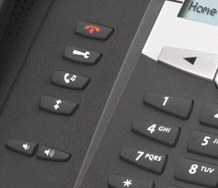
HOLD
Place a call on HOLD:
- From a conversation, press the HOLD key.
- The line/call appearance light will flash slowly.
Return to a call that is on HOLD:
Press the line key.

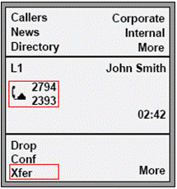
TRANSFER
- During the call press the TRANSFER softkey.
- Announce the call.
- Press the TRANSFER key again.
- Hang up.
*A softkey is a button alongside the display. The button label is shown on the display screen.
**Note that some phone models do not have softkeys. On these phones, check for a TRANSFER button among the programmable keys, which are blank buttons, with labels printed alongside.
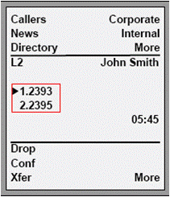
CONFERENCE (3 WAY)
- During a call, press the CONFERENCE softkey (see above notes).
- Call the third party and announce the conference.
- Press the CONFERENCE softkey again.
- All three parties will be connected in a conference.

CALL WAITING
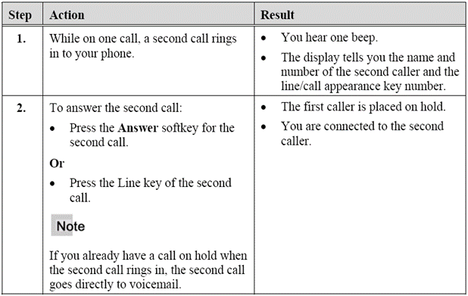

REDIAL
To REDIAL the last call you placed:
- Lift the handset and press the REDIAL button.
- The last number you dialed will be displayed.
- Press the REDIAL button again to place the call.
REDIAL LIST
You may REDIAL calls from a REDIAL LIST (previous calls):
- Press the REDIAL button while the handset is down (on hook).
- Use the up and down arrow keys beneath the display to scroll through the REDIAL LIST.
- When the number you wish to call is displayed, press the REDIAL button again and the displayed number will be called. For phone numbers outside of the University, you will need to select the “edit number” and insert an 8 to place the call.
- You may pick up the handset at this point.

CALL PARK
(A system type of HOLD that allows the held call to be picked up (answered) from any other phone in the system.)
To PARK a call:
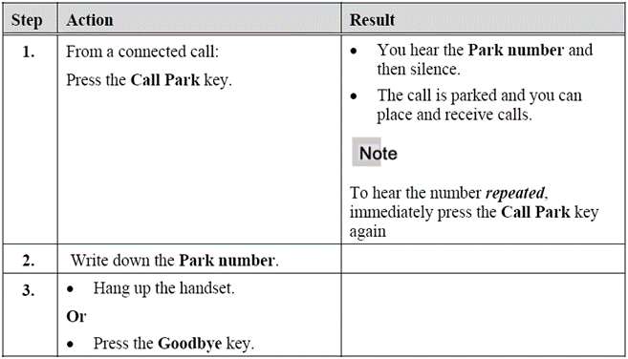
To retrieve a PARKED call:
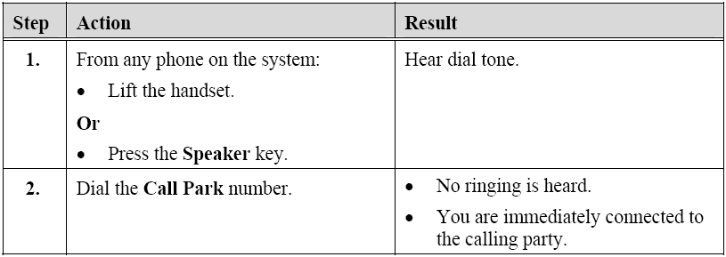

CALL PICKUP (GROUP)
You may pick up ringing calls to another phone in your preprogrammed CALL PICKUP GROUP.
- When another phone within your preprogrammed CALL PICKUP GROUP is ringing, lift your handset.
- Press the CALL PICKUP button (softkey or programmable key.)
- You are immediately connected. You will not hear a ring or a beep.
*To display the CALL PICKUP softkey, you may have to press the MORE softkey first.

CALL PICKUP (DIRECTED)
You may pick up ringing calls at any phone.
- When another phone outside of your CALL PICKUP GROUP is ringing, lift your handset.
- Press the CALL PICKUP button (softkey or programmable key.)
- Dial the extension of the ringing phone.
- You are immediately connected. You will not hear a ring or a beep.
*To display the CALL PICKUP softkey, you may have to press the MORE softkey first.

There are a number of PREFERENCES that may be set for each phone. Most of these have been set by OIT before your telephone was installed. They may be reset, though this is not recommended. Please refer to your complete Aastra Telephone Guide for information about resetting your PREFERENCES and for ADVANCED FEATURES instructions. The guide is found by going to http://www.oit.umn.edu/voice-services/, clicking on Telephone Guides (left menu) and then scrolling down the page to the phone that looks like yours (53i, 55i or 57i).

USING A HEADSET WITH YOUR TELEPHONE

Your Aastra VoIP phone accepts headsets through the modular jack on the back of the phone. The audio mode option (Options key) provides different combinations of these three methods to provide maximum flexibility in handling calls. A non-amplified headset is required. Customers should read and observe all safety recommendations contained in headset operating guides when using any headset.

Note: For best headset performance, Aastra recommends non-amplified headset equipped with modular connector.

MAKING AND RECEIVING CALLS USING A HEADSET

- Ensure that you have selected a headset audio mode by accessing the Options menu.
- Plug the headset into jack.
- Press the Speaker/Headset key to obtain dial tone or answer an incoming call. Depending on the audio mode selected from the Options menu, dial tone or an incoming call will be received on either the headset or the handsfree speakerphone.
- Press the Goodbye key to end the call.

Things to know:
Your System Administrator is 1-HELP. When this guide asks you to check with your System Administrator, please call 1-HELP (1-4357).
1-HELP may ask you for your phone’s IP and MAC addresses. To find these, press the Options key (on the left). Then press 2 for Phone Status, followed by 1 for IP & MAC Addresses. After making a note of these, press Done to return your phone to its resting state.
It is not recommended that you make changes to your phone’s settings. You may, however, find it necessary to change the display lighting or ringtone. If so, press the Options key, they 1 for Preferences. Select the setting you wish to change and follow the screen instructions.
Softkeys: When you pick up the handset or press the speaker button (go on line), the softkey labels will change to features that are associated with a call that is in progress. When you hang up, the softkey labels will return to those displayed when the phone is at rest.
Example: The transfer softkey (Xfer) label will only show up when a call is in progress (the handset is picked up or the speaker button has been pressed).

For more detailed instructions for Preferences, Speed Dial Lists, Caller Lists and the Missed Calls Indicator, please refer to the Aastra VoIP User Guide found at http://www.oit.umn.edu/voice-services/telephone-guides/index.htm (select phone type).

