Risk Management Guide

Section 1 – Purpose
The Risk Management Plan defines the risk management process, the roles and responsibilities of project team members in the risk management process, and key business rules.
A risk is defined as an event that could endanger the planned course or goals of the project.
Any risks that are identified should utilize the risk management process as defined in the Risk Management Plan. The risk management process helps to ensure that the risk is analyzed and quantified and that the appropriate steps are taken to manage or mitigate the potential risk.

Section 2 – Risk Management Process
The following diagram portrays the risk management process.

Section 2 – Risk Management Process

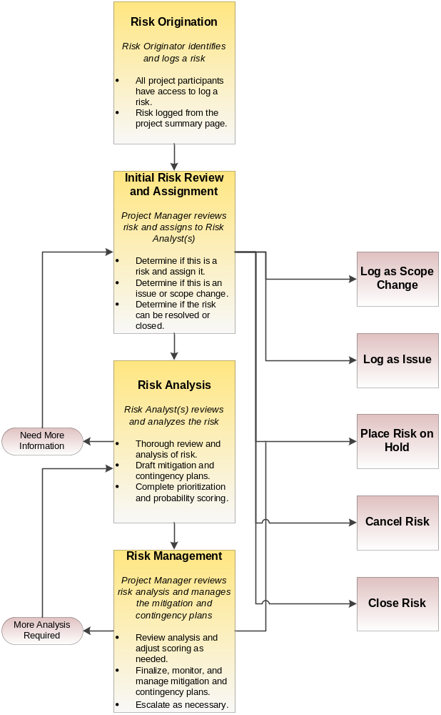

Section 3 – Roles and Responsibilities
Role | Responsibilities
Risk Originator | - Identifies a risk and enters appropriate information about the risk into the project risk log.
Project Manager | - Tracks the status of risks and maintains the project risk log.  - Reviews and assigns risks submitted by project team members.  - Clarifies risk description and detail with Risk Originator if necessary.  - Reviews risk analysis and finalizes mitigation and contingency plans.  - Approves low impact resolution recommendations.  - Reviews risk and risk status with project team on a regular basis.  - Escalates risk, impact analysis, and mitigation and contingency plans to the Project Sponsor and / or appropriate management as needed.  - Obtains appropriate approvals.  - Updates project plan as needed.
Risk Analyst | - Reviews risk assigned by Project Manager.  - Researches and clarifies risk.  - Conducts technical review and detailed analysis of risk.  - Updates functional and technical specifications as needed.  - Drafts a mitigation strategy and contingency plan.  - Completes prioritization and probability scoring for risk.  - Updates risk log with appropriate information as needed.
Project Sponsor | - Reviews risk, impact analysis, and mitigation strategy and contingency plan as needed.  - Approves, denies, or puts the risk on hold as needed.  - Ensures additional resources are available as needed.

Section 4 – Risk Management Rules
The following rules apply to the risk management process.
- All risks will go through the risk management process identified in this document.
- A mitigation plan will be developed for each identified risk to either reduce the probability of the risk materializing or the severity of the exposure if it does.
- The individual responsible for executing a risk mitigation plan is also responsible for carrying out the mitigation activities.
- A risk may be escalated to the appropriate level of management if the mitigation actions are not effective or the exposure is rising.
- The Project Manager may approve risk management plans having little to no impact on the project.
  - The Project Sponsor will be notified of the approval during the project status meetings or by the project status report.
- Any risks forwarded to the Project Sponsor will also be forwarded to the appropriate management staff.
- Any risks forwarded to the Executive Sponsor will also be forwarded to the Project Sponsor.
- A risk will be considered closed when the planned mitigation actions have been completed and the estimated risk exposure of probability times impact is less than 2.

